**BOUNDARY DETECTION**

i=imread('2016_volkswagen_tiguan_suv-wallpaper-960x540.jpg');

imshow(i),title('Original image');

i=rgb2gray(i);

figure,imshow(i),title('Gray image');

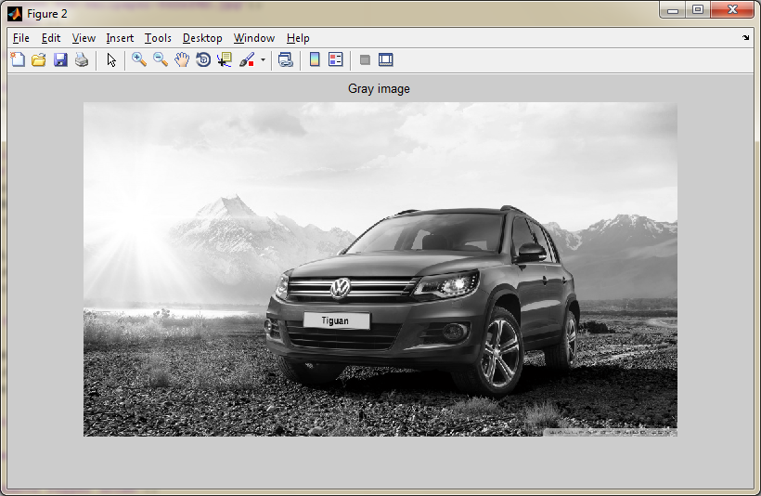

**Sobel Edge Dedector:**

g=edge(i,'sobel');

figure,imshow(g);

title('Sobel edge detector');

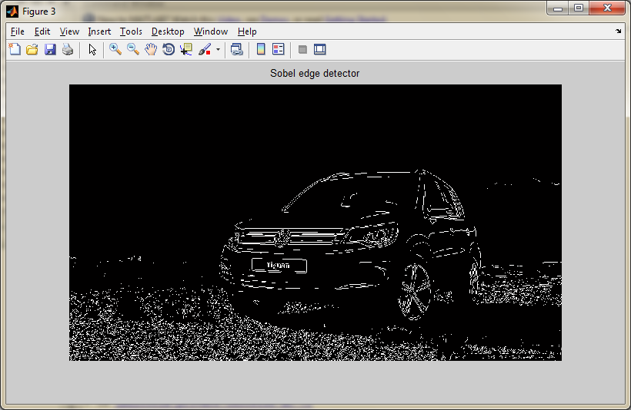

**Dilated Image:**

se90 = strel('line', 3, 90);

se0 = strel('line', 3, 0);

d=imdilate(i,[se90 se0]);

figure,imshow(d);

title('Dilated image');

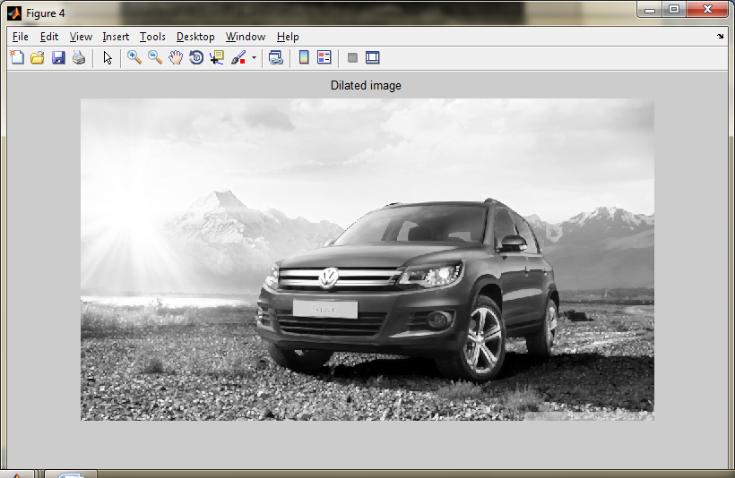

BWdfill = imfill(d, 'holes');

figure, imshow(BWdfill);

title('binary image with filled holes');

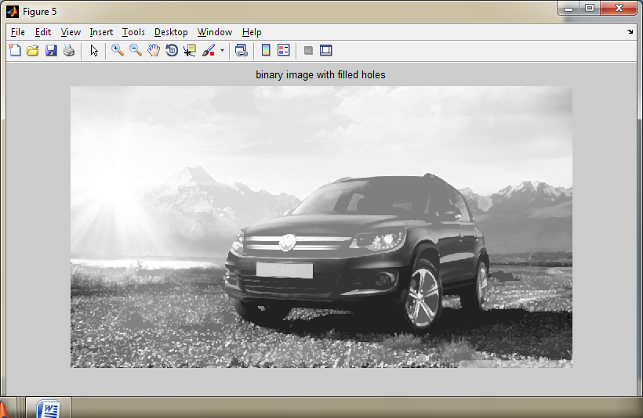

BWnobord = imclearborder(BWdfill, 4);

figure, imshow(BWnobord), title('cleared border image');

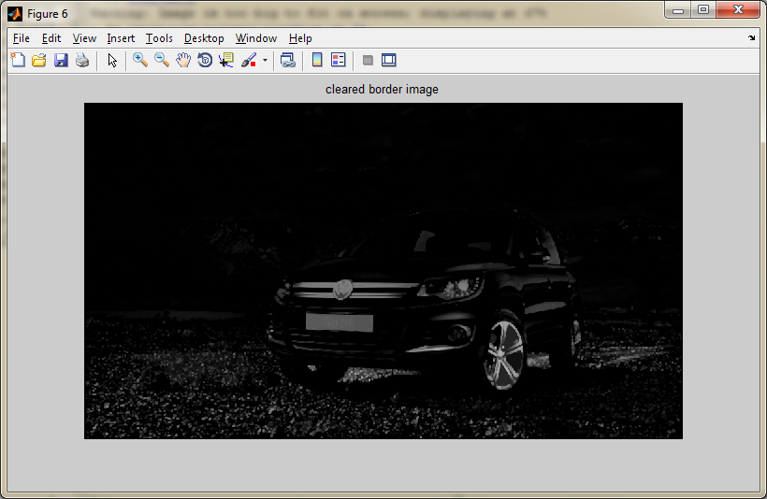

seD = strel('diamond',1);

BWfinal = imerode(BWnobord,seD);

BWfinal = imerode(BWfinal,seD);

figure, imshow(BWfinal), title('Extraction of Erosion');

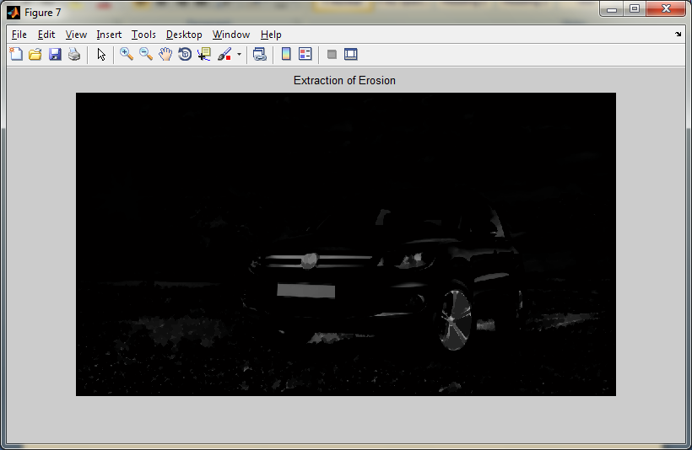

noise_g=imnoise(i,'Salt & Pepper');

disk=strel('disk',2);

no_salt=imopen(noise_g,disk);

no_pepper=imclose(noise_g,disk);

no_saltandpepper=imclose(no_salt,disk);

subplot(2,2,1);

imshow(noise_g),title('Salt and Pepper noise');

subplot(2,2,2);

imshow(no_salt),title('Remove salt noise');

subplot(2,2,3);

imshow(no_pepper),title('Remove Pepper noise');

subplot(2,2,4);

imshow(no_saltandpepper),title('Remove Salt and Pepper noise');

